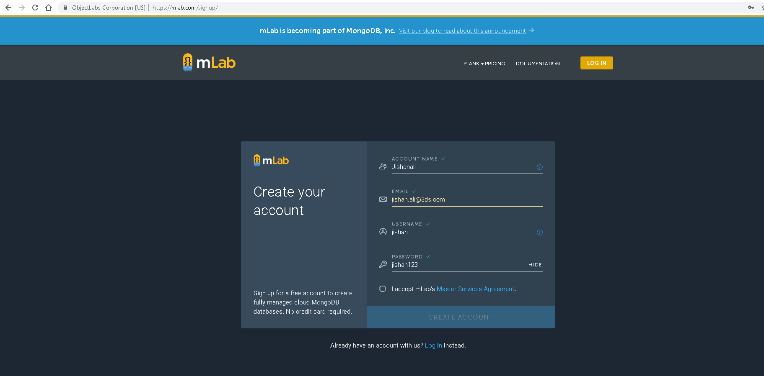

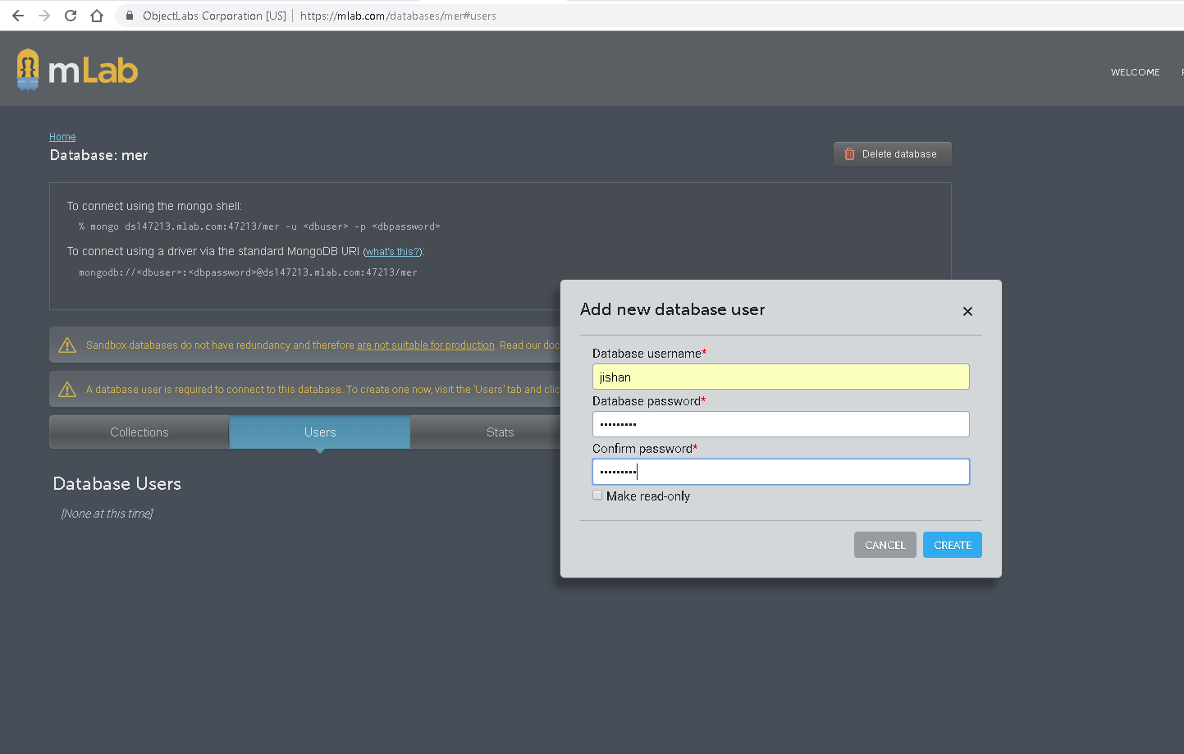

Password – jishan123

MongoDB tutorial Lynda

Install mongodb

Add path to environment variables - C:\Program Files\MongoDB\Server\4.0\bin

And now you should be able to start both the Mongo server and the Mongo shell from the command line. So the first thing we need to do is create a data directory.

So we'll start the command prompt and do md \data. So we'll start with making the directory of data and the second thing we'll create is data DB. This is the file that Mongo is going to look for to use to store information about the database. So now you can start MongoD. It's not MongoDB, it's MongoD because it's the Mongo daemon. And you can see that it's actually started up.

**mongod - This is MongoDB Server, continuously waiting for client to connect**

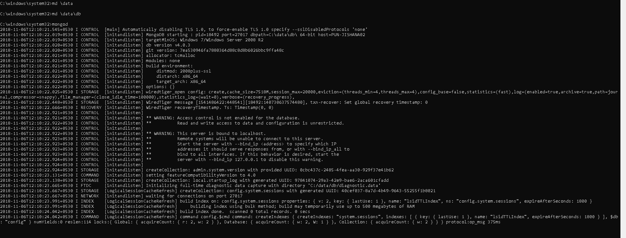

So let's open another command prompt.

And type Mongo. You can see that we have to start it off in the shell. So to make sure that everything works, let's go ahead and insert a file into the database.

**mongo - This is MongoDB client connecting and querying to Server**

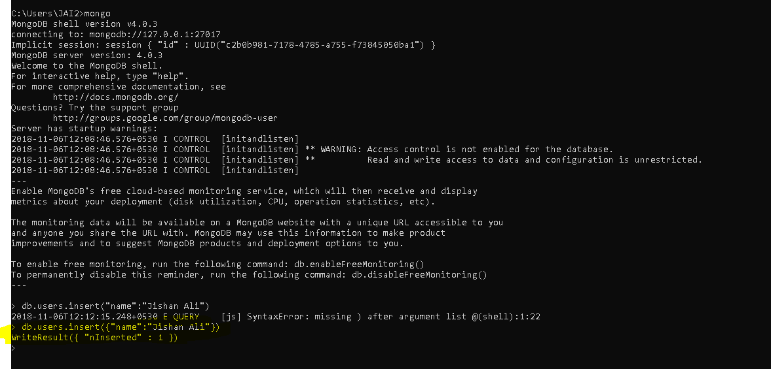

MongoDB doesn’t have tables it has collections. Because it is a noSQL database it has JSON formatted approach.

Here users is a collection

# Why Mango ?

Relational databases can be very complex for relatively simple schemas. For instance, a user in the system might have one or more addresses, phone numbers, or job titles. In order to retrieve information about one single entity, multiple tables need to be queried and the data tied together. This image shows the pieces necessary to show the data for just one user.

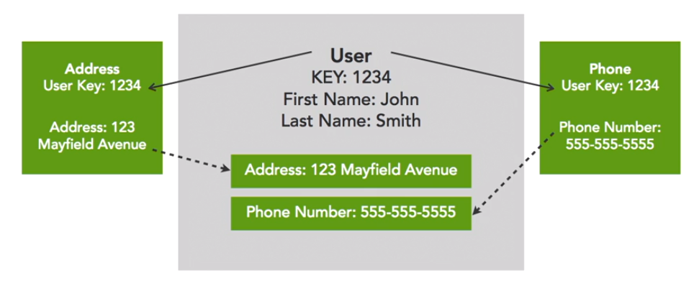

Creating relational database schemas can have several disadvantages. 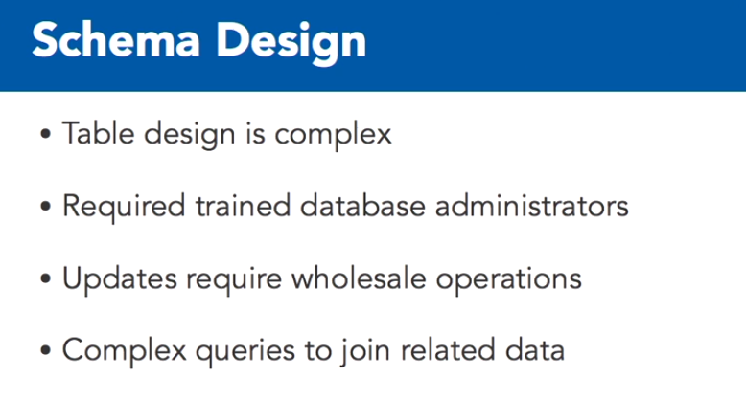

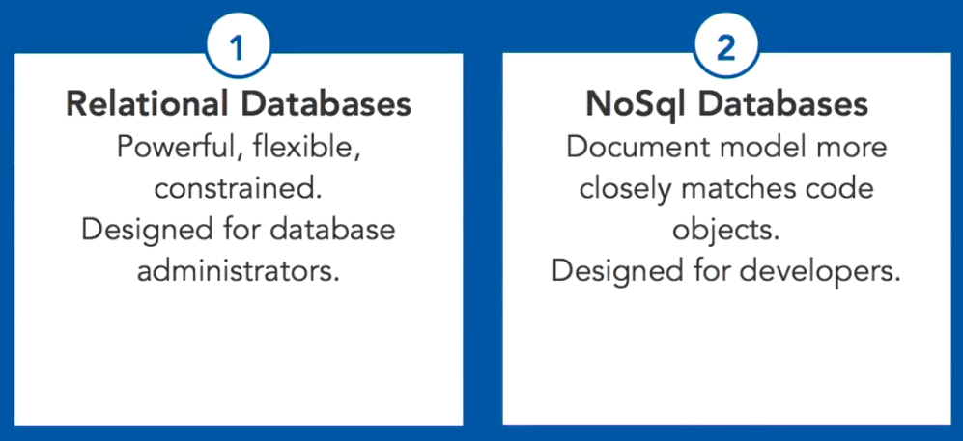

Gathering appropriate information can be expensive in terms of time and resources when multiple intersecting joins are needed to aggregate information. 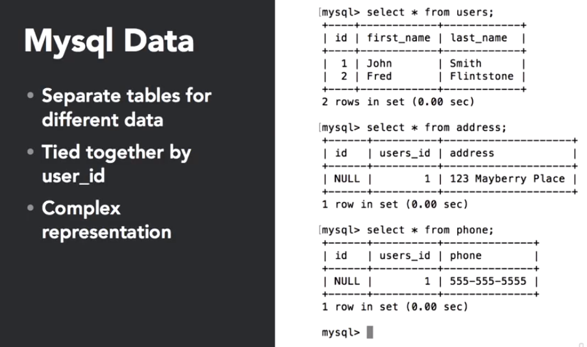

 Here's an example of the call needed to find all the users named John in the system along with their related contact information. When the data is returned, it is combined into a single table with the requested information. 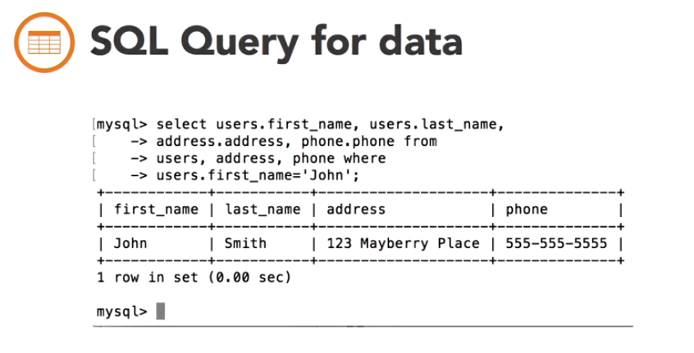

**A document database, on the other hand, keeps all of the related information contained in the same object, so it's easier to access the information.**

On this screen, the Mongo shell is started. The first item is inserted into the users collection. Note that this collection is created dynamicallywhen the item is inserted. After the second item is input, it's a simple request to get a list of all items in the database.

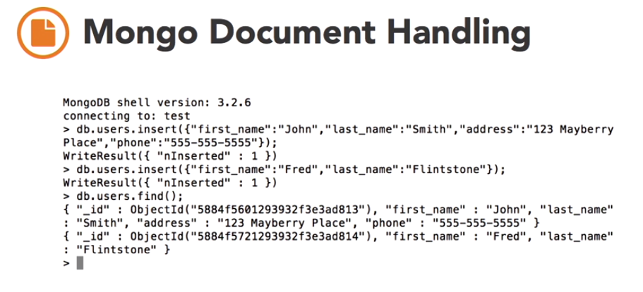

Here's a request for all the documents in the system containing John as the first name. When making your requests for documents in Mongo, you include a document in the request describing the characteristics of the objects you want to get back. The documents themselves already contain all of the appropriate fields, so no specific join operation needs to happen.

The second example here shows one of the great features of Mongo. When a document doesn't match the exact query, it simply isn't returned. No error is returned for the missing field.

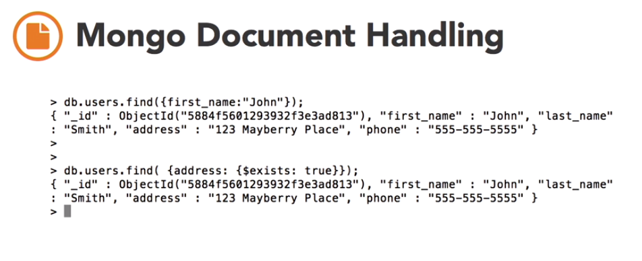

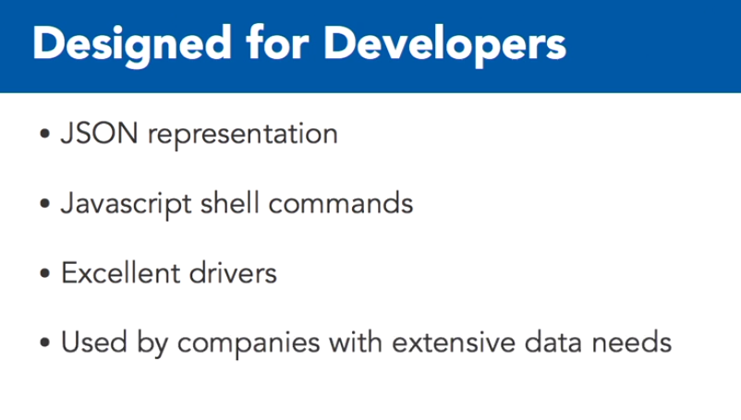

# Document oriented data

A document in a Mongo database is simply a JSON object. The data is actually stored in a related binary format known as BSON, but all of your interactions with the data will use JSON, regardless of the language or driver you use. Storing the data this way makes it much easier to access related information. Searching on specific attributes of an object or sorting items based on a field works naturally and quickly.

Indices can be created across different fields in the collection documents. Working with JSON, a common format, makes it easy to adapt the data to your personal development environment.

what does a MongoDB item look like?

 In the most basic form, let's look at the user we created earlier. When I inserted the object, it looked like this. This is a flat object with no nested items, a very simple JSON representation of this resource.

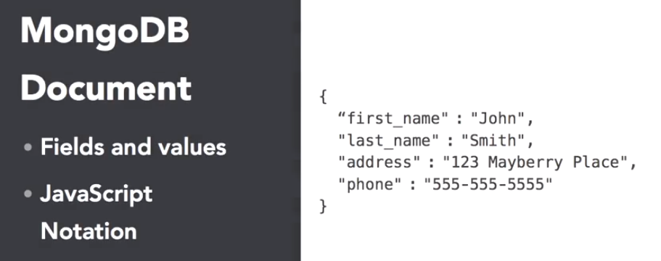

You may have noticed that the object returned by Mongo had an additional field, the _id field.

Every item in a Mongo database has this field. If it's not specified at the time the object is created, one will be assigned by Mongo. This field must be unique across a specific collection, but otherwise can be any identifying string you wish to use if you don't want to work directly with the Mongo IDs. 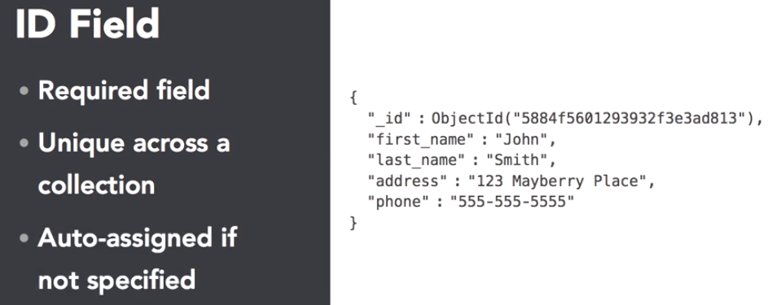

the query language used by Mongo relies heavily on documents to know what objects to operateon. 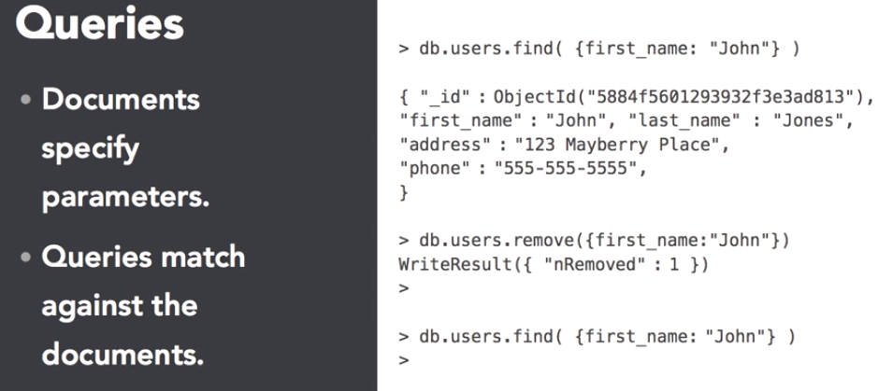

When we rerun the request to find all the John entries, we get no results, which is what we'd expect.

The update seen here updates all of the items in the database with John as the first name and sets the value specified here. **Note, the update is a complete overwrite. If you had left out the address and phone, John would only have first and last names.** The original update could have been done with the set operator, and this operation leaves all of the remaining fields in place. It's likely that you'll use set much more oftenthan a bare update, because most changes to a database are additive and adding new fields can easily be done with this operation. 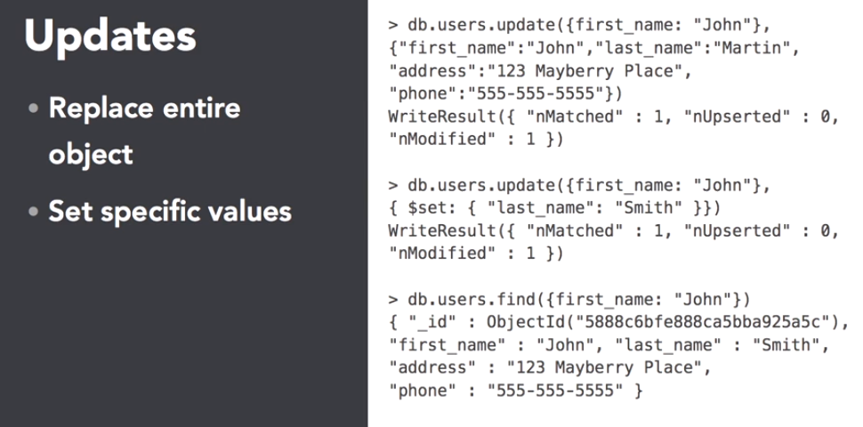

Mongo documents also support nested objects, objects which are deeper than a single set of keys and values. Here, we're giving John multiple phone numbers represented as an array in the data. With this simple array, we can do a search to find our matching items, which is really quite cool. And Mongo supports nesting up to 100 levels. You're unlikely to need anything remotely close to that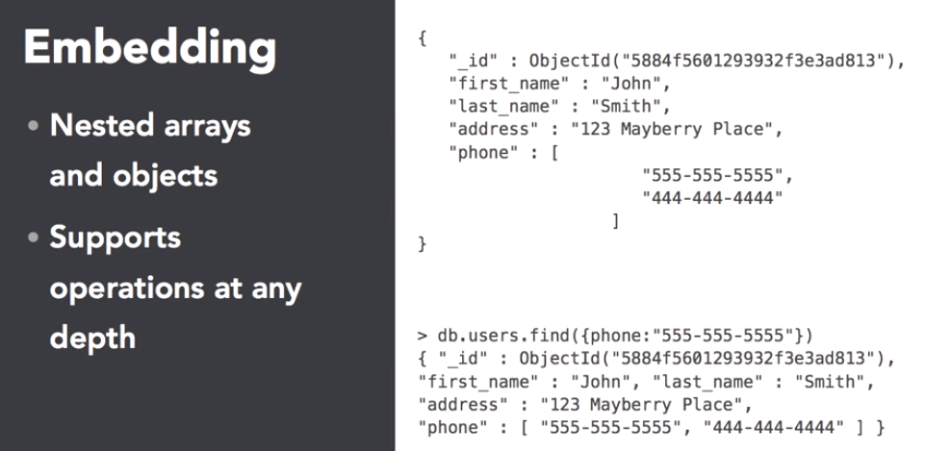

but how can you access exactly what you want in a richly defined object? While we'll dive into this more deeply later, here are a few examples of the types of interactions you could do with this data.

Find the users with the matching fax number and return just the phone number. Find the user with the matching nested phone number. Note, we'll learn more about the dot notation you see here as we go through the query section. And finally, give me just the phone numbers for everyone in the database.

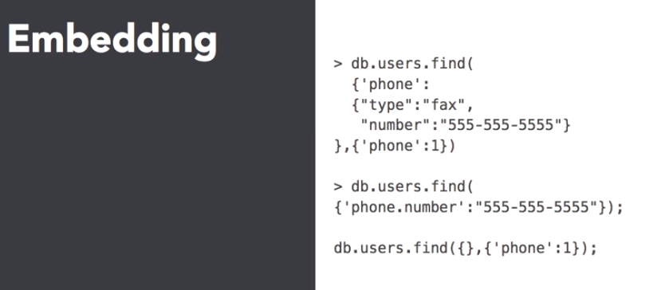

# Embed or Reference

When determining the schema for your database you will come across places where you need to choose how much data to include within each of your documents. Mongo DB supports, as I mentioned, a hundred levels of depth for your documents. Obviously, this could become quite unwieldy and very deep data structures can in fact slow your indexing, access, and storage.

Let's take a quick look at the advantages and disadvantages of each approach.

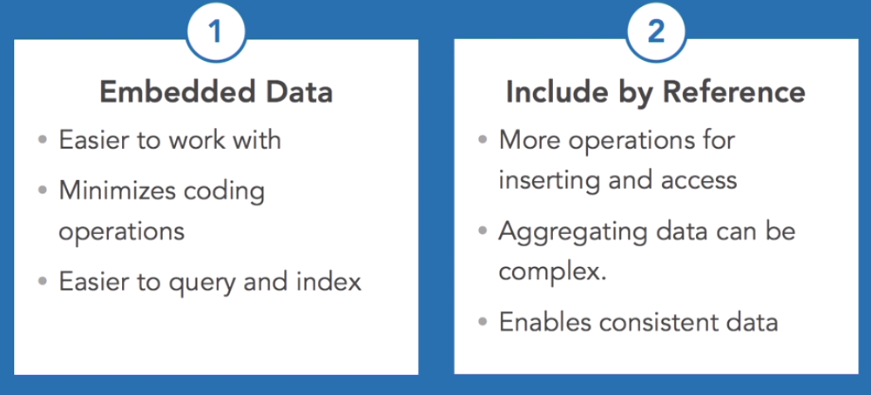

As an example, let's create a schema for a combination Wiki Blog system.



Here's a basic layout for the types of data we'll need to work with. Each Wiki page or blog entry will be a page, so that can be consistent across both data types. All entries can have authors and tags, and blog posts can have comments.

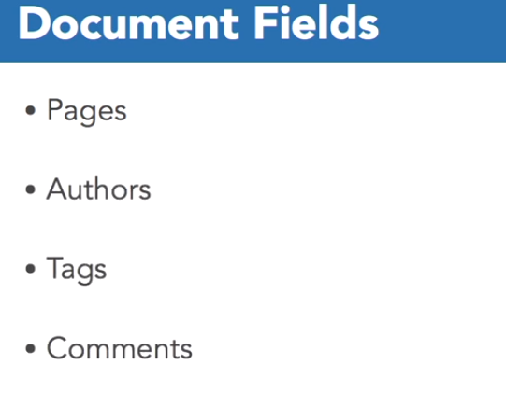

So what are our choices for modeling this type of data structure?

First, let's look at this using embedding, where every document has all of the information needed included in the document. We'll combine the two types of information into a single collection named Pages.

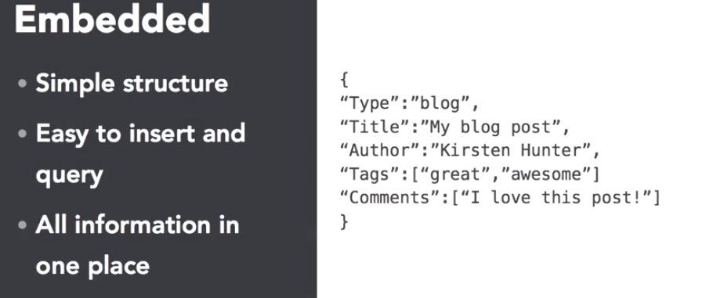

With this set up, we've got a lot of great functionality available. 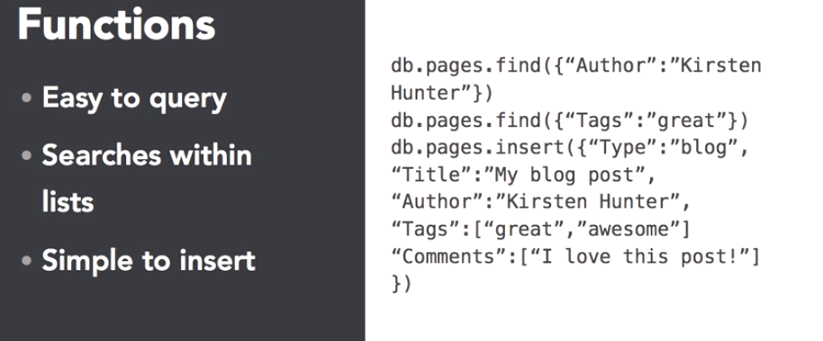

But what if we wanted to extend this information and add extra data about the related items?

Now we've got more information about the author and the comments. Still, it's easy for us to search for items, but now we've got a situation where every time an author appears, we're repeating the same information. What if my Twitter handle changes? What if I wanted to add a website? I'd have to update every document with that author in order to keep everything in sync.

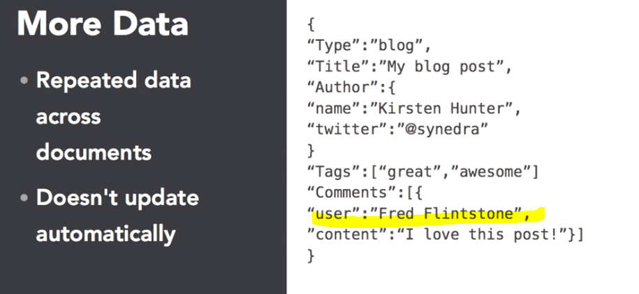

Well the flexibility and document organization in Mongo DB allows for a great deal of ease in development. There are many cases where you might want to break out the related data and refer to it separately instead of including it in the document itself. How would you do that? There are a couple of different approaches here. The strictest method is to simply include the ID for the item, and create the code to gather the information you want to find. The example here shows how you would find all the pages related to the user Fred Flintstone for an embedded document.

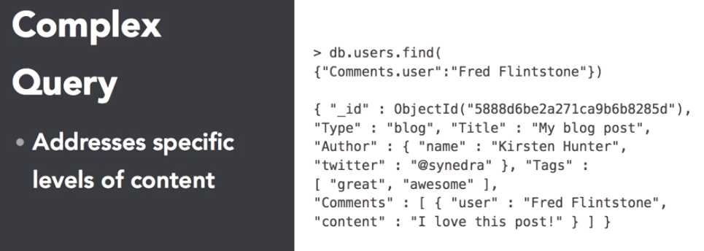

**Now let's look at a setup using references.** This is a little more complicated, and you don't need to understand the whole thing as we'll be covering it in more detail later. But this gives an idea about the process you'd follow to find all the pages with comments by a specific user.

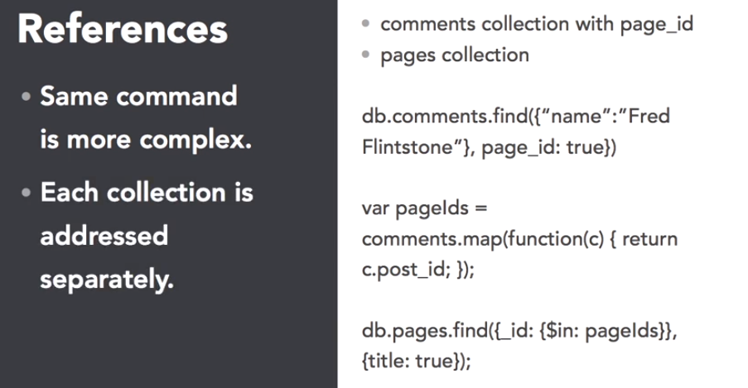

**When deciding on a strategy, it's important to figure out what the use cases are you're trying to support. Anytime you'll be reusing an object in multiple places, it's worth considering whether you should break that information out into a separate collection. While it's true that you need to perform extra steps to get the information you want, it also protects you from the problem of maintaining identical information in multiple places.**

# **Performance**

Documentation remaining…

# Explore the Mongo shell

By default, you're connected to the test database. You can see this by typing DB at the prompt. Let's use a different database for our course by typing

use learning_mongo

Now we're using the database Learning Mongo. **Note that even though the Learning Mongo database didn't exist, Mongo switched our context appropriately.**

**When you show DBs, you can see that Learning Mongo doesn't show up yet. It's going to be completely created when the first document is inserted**

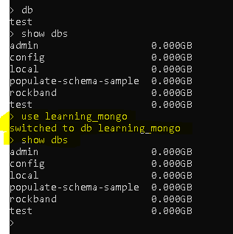

Mongo stores data in databases which are separated into collections of documents. To create a new collection, we simply need to insert a document and the collection will be created as a side effect.

Okay. It inserted one item. This is going to happen in the database we selected. Now we've inserted a new car into our cars collection in our database. Let's look at the show DBs command again, Look, Learning Mongo has shown up now. Let's see what collections we've got. So show collections is how you do that, and we have cars. So we have the Learning Mongo database and we have the cars collection.

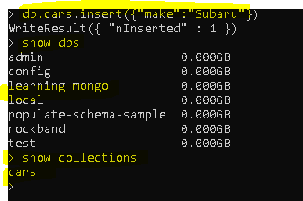

As you can see, Mongo's very friendly when it comes to adding data since it doesn't require a schema, no setup work is needed in order to start working with data. The commands we typed are very similar in many cases to what you might have seen in SQL, but **the Mongo shell is special in that it uses a JavaScript interpreter. You can interact with the database using JavaScript Expressions**, making it easy to perform various tasks.

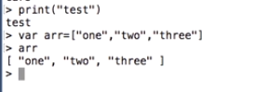

Let's create a very basic collection of numbers.

It's going to take some time to complete, so just be patient. We're inserting 10,000 records into the database.

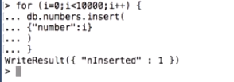

Now while this is running, note that I was able to put the command on multiple lines. This allows us to break up complex commands into much more digestible chunks. Let's take a closer look at the code I typed in. We're mixing native JavaScript with the Mongo DB interaction functions. This gives a huge amount of flexibility and power when working in the Mongo shell. **Even though it says there was only one insert,it's counting the number of operations, not individual documents**. Once the records have been inserted, we can grab a count to see how many we've got.

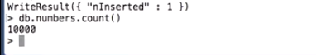

Let's take a look at what Mongo's doing with the query and add some debugging. So we're going to do a find with the number one and we're going to say explain.

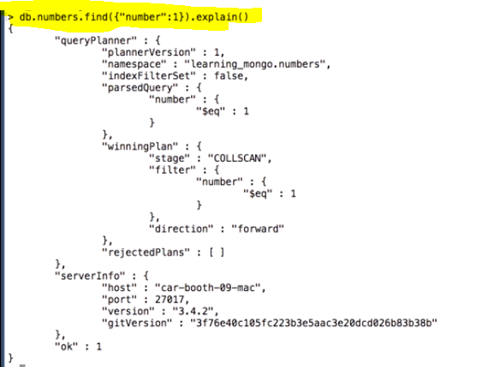

So we got a lot of information here about the query planner, it tells us how it was planning to figure out what query to run, but it didn't tell us much about the actual execution.

So what we're going to do is we're going to say explain(execution_Stats). And we get a little bit more information.

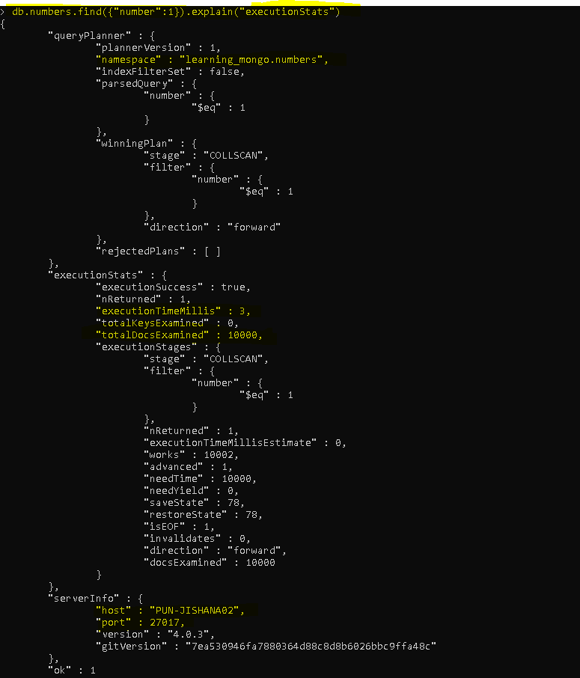

you can see it examined all 10,000 documents and it only took 3 milliseconds because there were not that many documents or keys to look at.

but we don't want it to examine 10,000 documents in order to return a single one.

## ???? doubt about how we are indexing single document???? Do we need to index every single document??

Let's add a simple index to see how it changes the outcome. So db.numbers.createIndex({number:1}).

Now notice this is very similar to what we had before, but we're creating an index, not doing a find, and the **number is a special variable**. **We're not using number as a string.** So we created an index, it didn't have to create the collection automatically cause we've already created the numbers collection.

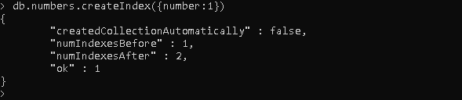

let's try the executionStats again and see what happened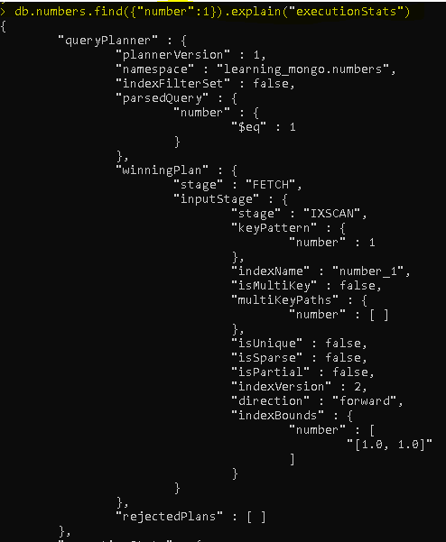

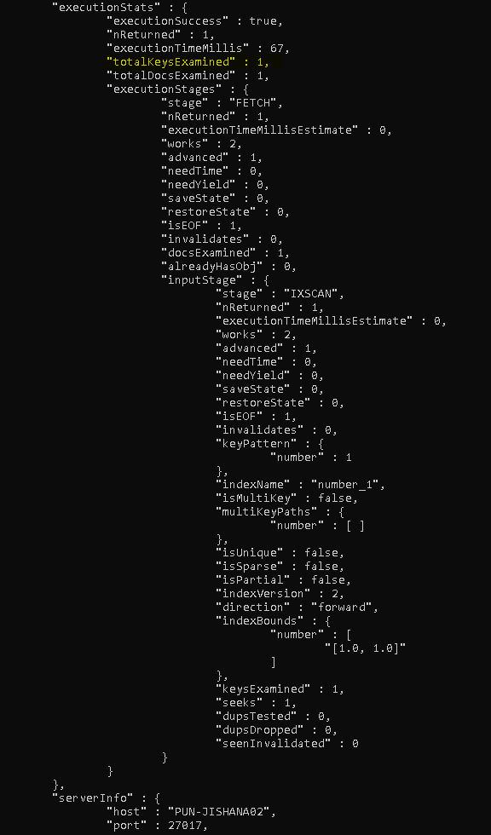

Since we were putting an index on exactly what we were searching for, it only had to examineone document in order to find what it was looking for. In a 10,000 database it doesn't make a huge difference in how long it takes to run, but in a larger database, it can make a huge difference. Using this simple index reduces the execution time to almost nothing even for very large datasets.

# Import the data into database

Inserting data into mongo using the shell or one of the language drivers is handy but in many case you already have data that you want to import into your database. Whether that data is in json, csv or tsv the mongo import command can do the work for you without the need to write your own code.

mongoimport --help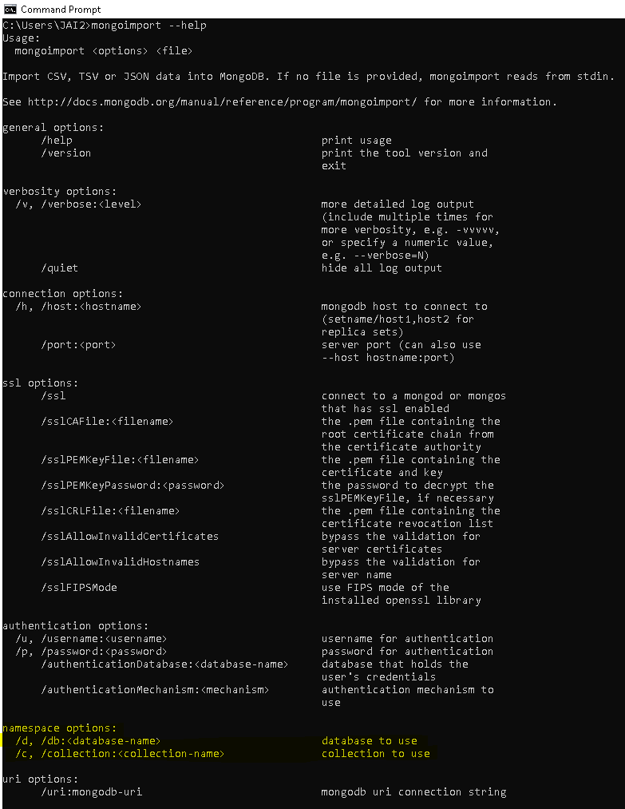

here’s the tour.json file which we are going to import in our database

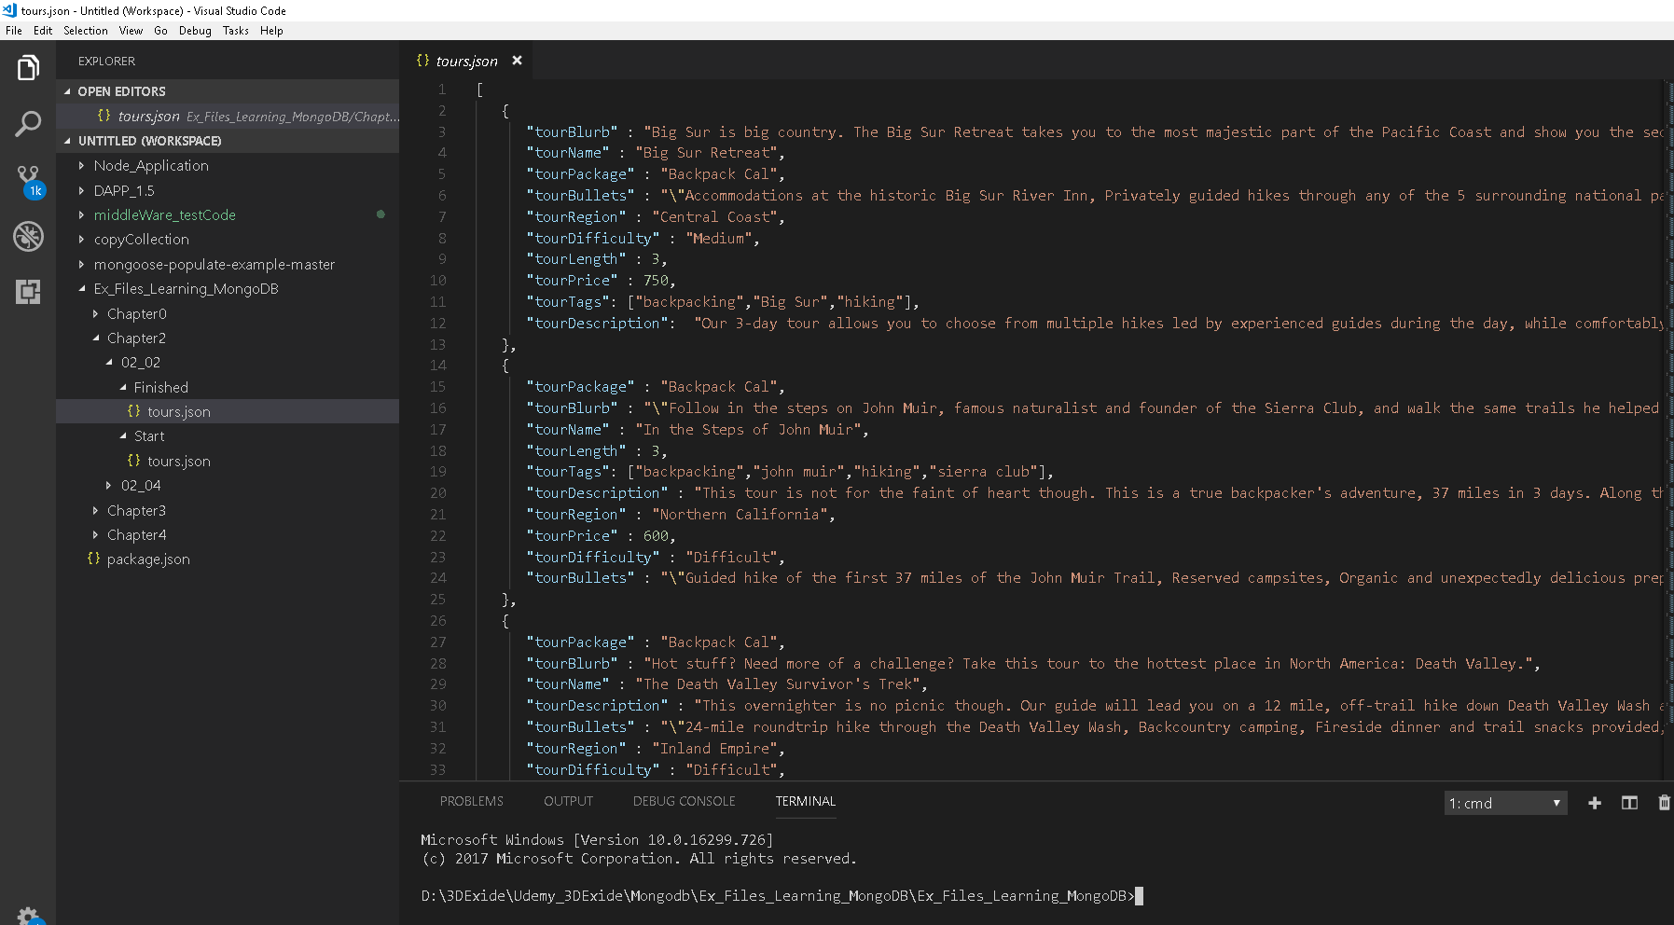

## Note –

Note that the few of the tours aren't the same as the others they don't have a tour region. Let's take look at a week of line as an example. This tour doesn't have a region but it has all the other fields available and will import without trouble. Because mongo doesn't impose a structure or schema you need to make sure that the data you're importing matches what you want to be in the database. In this case it's fine. If someone is querying specifically on the region of the tour the non-matching object simply won't be returned which is the right behavior. 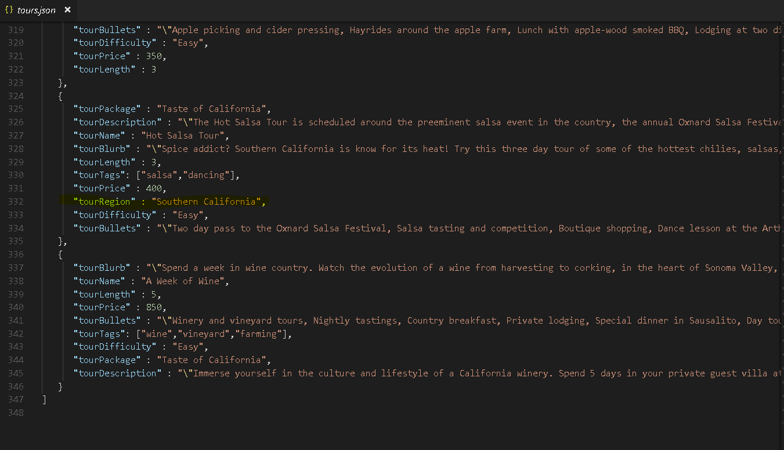

Use mongoimport to import your data into database

mongoimport --db learning_mongo --collection tours --jsonArray --file D:\3DExide\Udemy_3DExide\Mongodb\Ex_Files_Learning_MongoDB\Ex_Files_Learning_MongoDB\Chapter2\02_04\Finished\tours.json



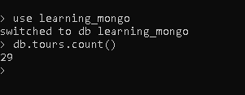

# Mongo shell(mongo client) operations

Lets try some CRUD operations in database ‘learning_mongo’ and collection ‘tours’

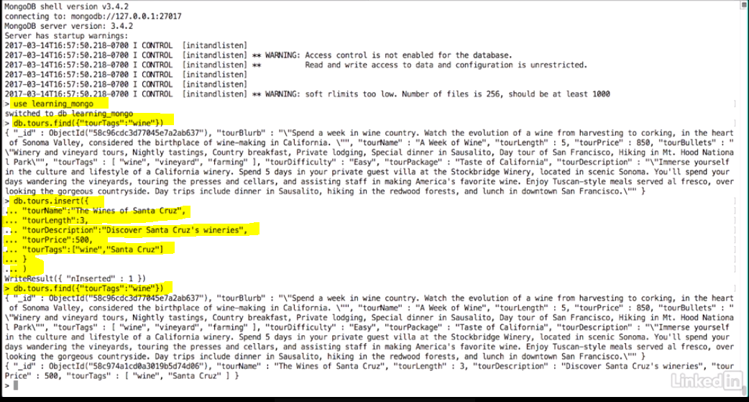

Let's update the tour to add a region so people know where the tour is located.

**As discussed in the section on mongo operations, updates can be done to replace the entire document or just update a subset of the data.**

In this case, we want to add a region to the tour and leave the rest of the document as-is.

We'll use the set functionality to do that.

So db.tours.update tourName The Wines of Santa Cruz. That's the first part, where we're setting exactly what we want to find. We want to find the tour with the tourName The Wines of Santa Cruz.

And now we're going to put a comma and another document. So set tourRegion Central Coast. So we went ahead and modified it.

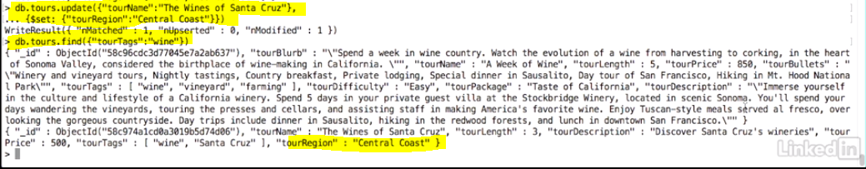

but what if we wanted to add a new entry in tourTags for the document? That's an array, so we need to use a different operator to add a new tag without removing the other ones.

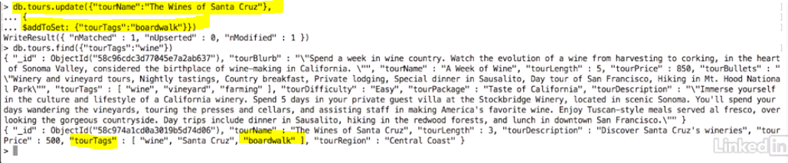

**Delete a document from collection -**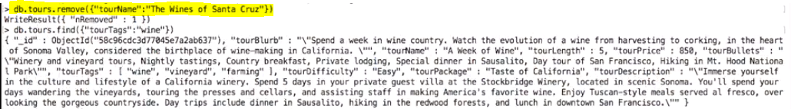

**Delete a collection –**



**The documentation on the mongo site is quite helpful if you want to explore the different commands.**

# Indexing

Indexes are very important in any database, and with MongoDB it's no different. With the use of Indexes, performing queries in MongoDB becomes more efficient.

If you had a collection with thousands of documents with no indexes, and then you query to find certain documents, then in such case MongoDB would need to scan the entire collection to find the documents. But if you had indexes, MongoDB would use these indexes to limit the number of documents that had to be searched in the collection.

Indexes are special data sets which store a partial part of the collection's data. Since the data is partial, it becomes easier to read this data. This partial set stores the value of a specific field or a set of fields ordered by the value of the field.

## Mongodb createIndex() – Create Indexes

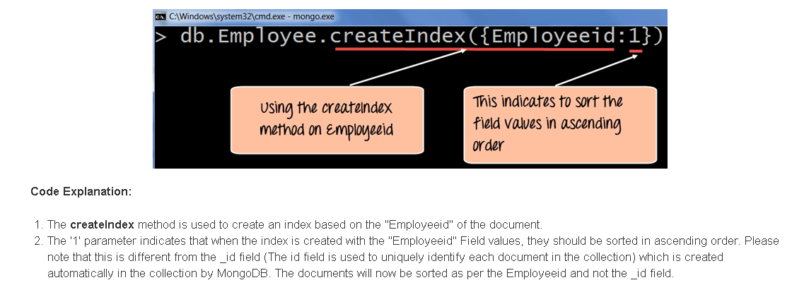

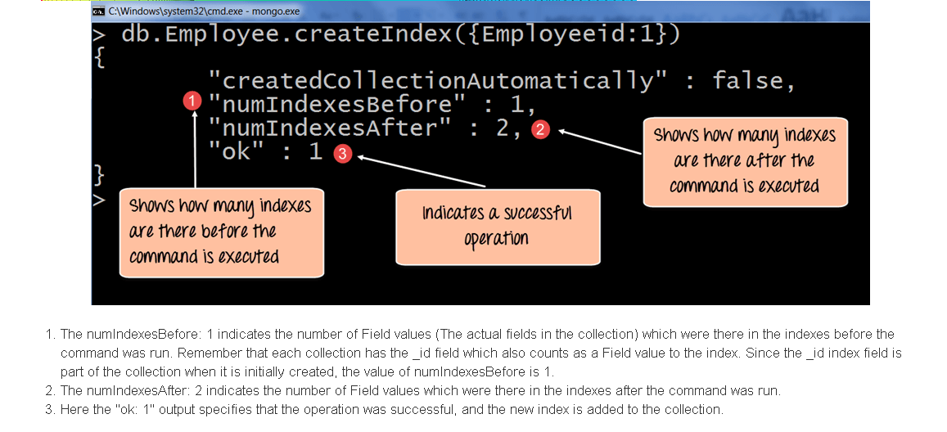

one can also create an index based on multiple field values.

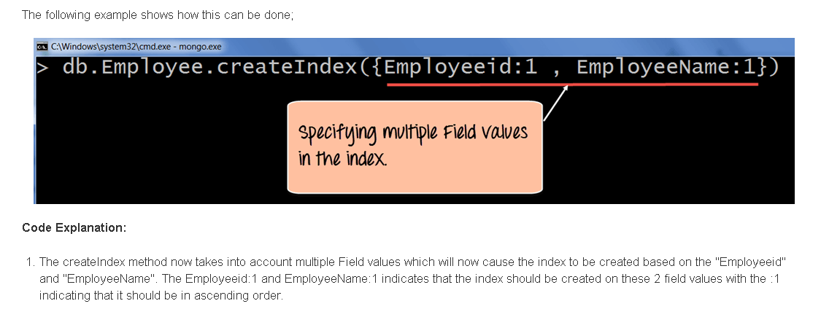

Here’s an example with our Database in mongodb

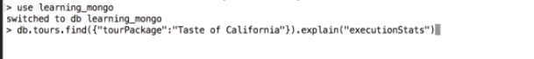

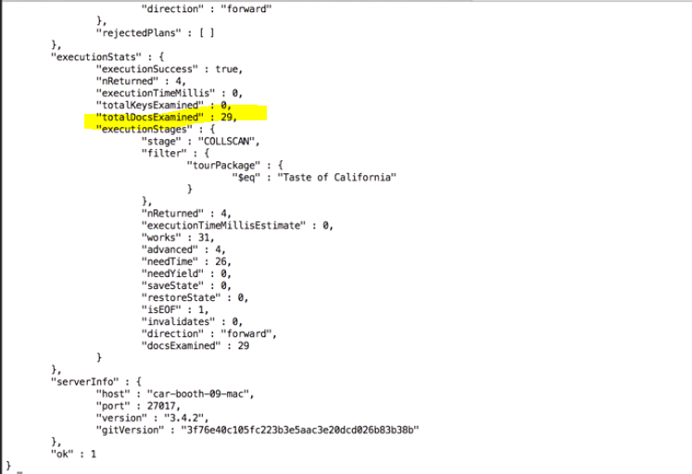

under the executionStats, you can see that it examined all 29 documents. It didn't take very long because it was a very easy query, but we don't want it to look at very single document in order to find the answer. So, we're going to create the index

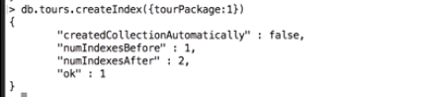

we have the tourPackage here. It's not with quotes. This is how we refer to it when we're doing the indexes.

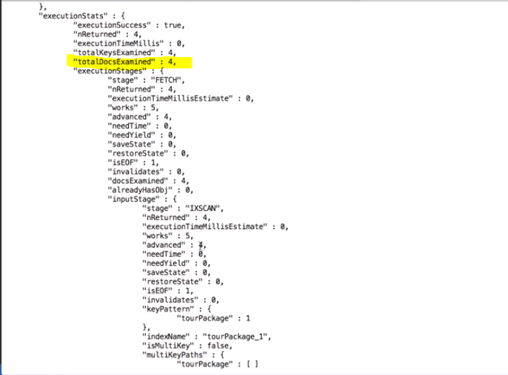

You can create up to 64 indexes per collection in Mongo. But, in most cases, you'll need just a few to support your most common use cases.Any time you're consistently running into performance issues with queries, you should consider whether an index would help with the request.

# Node Mongodb setup

the same interfaces covered in the Mongo shell work here as well for all CRUD operations. To review what those were, create is insert, read is find or find one, update is update, and delete is delete.

# Unique Indexes

When working with a database, frequently you need to be able to impose constraints on the data. The most common use case is requiring that a particular field be unique across the collection. The underscore ID field can be set when the document is inserted, but in many cases, you'll want to be able to impose this kind of restriction on other fields.

The first thing we need to do is drop all the items from the Tours collection. Those items weren't created with a unique constraint.

Adding a unique index to the documents only enforces it for entries happening after the index is created. So if you know that you want to use a unique index, you can either set the underscore ID when creating the document, or declare one of the fields to be a unique index before adding documents to the collection.

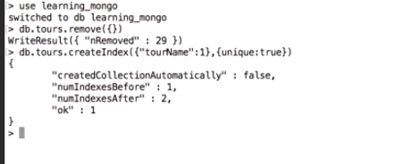

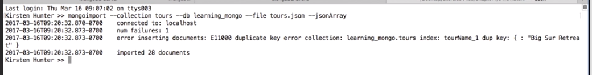

We got an error although it's a very useful error, it does tell us that the problem is that there's a duplicate key. We need to fix up the tours.json file so we don't have a duplicate anymore.

So we change the duplicates



This time it imported the documents. Great, so the unique index made it possible to make sure that the data was structured correctly.

Now, let's create a unique key by using the underscore ID field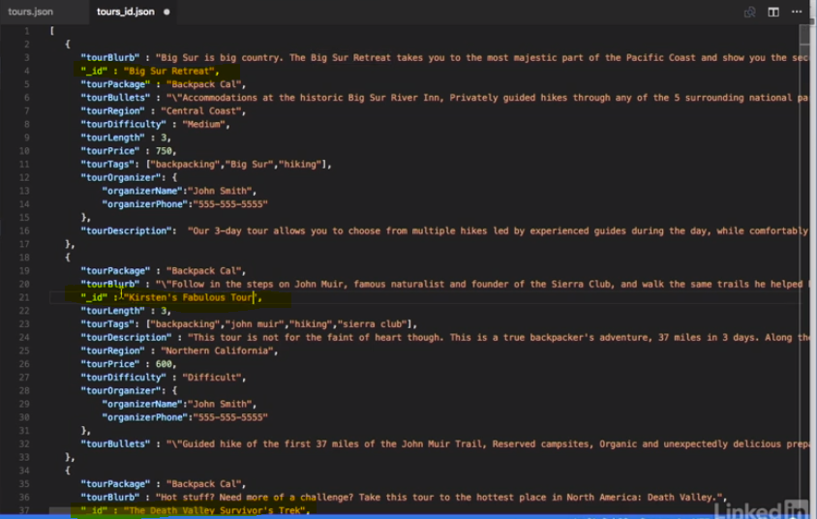



# Tune/Customize the mongo output/queries

Let's grab all the documents in the collection.

Alright, as it's been throughout the course, this is not really formatted and it's hard to parse. Let's make the return a little bit nicer. MongoDB supports projections, which allow you to specify which pieces of the documents you want to see. The simplest example of this is to request a specific field, or set of fields from the document. Let's just take a look at the tourNames and see what's up. So we have to say the empty document and then **tourName:1 (1 means in ascending order).**

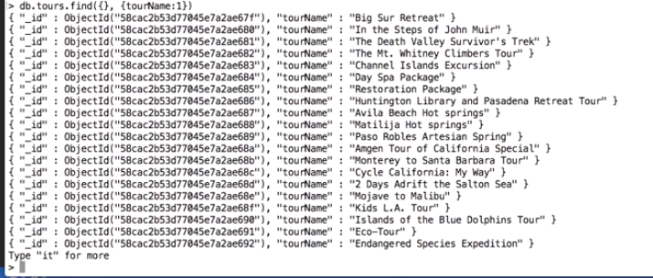

we also got the underscore id field as well as the tourName. It turns out that Mongo's always going to return this field, unless you specify that it should be excluded. So let's do that by extending the query. _id : 0. 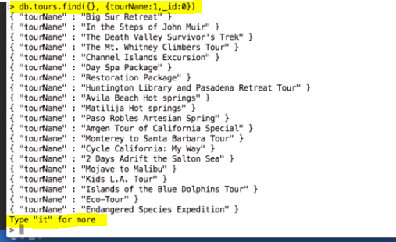

let's grab a couple more fields

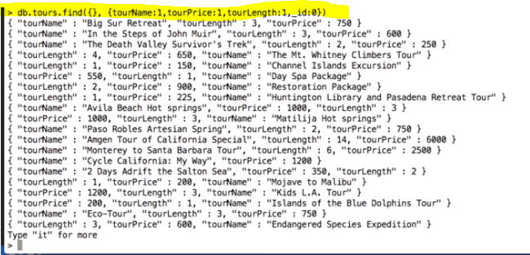

we're getting the information that we want and it's starting to look a little bit hard to read again. Fortunately Mongo has something called pretty, a little function you can chain on there and it makes the output a lot easier to parse.



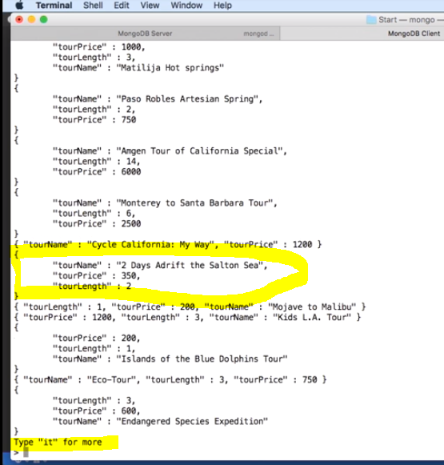

if you look at the bottom of the response, you see Type it for more, which indicates that not all of the documents were returned.

We're going to need to implement some kind of sorting to make sure that the best options show up at the top and we can just add this function to the chain we're building.

**So dot sort, and we want to sort on tourPrice and we want to do it descending, so that the people are more likely to spend more money.There we go. Now we've got it sorted in reverse order by price. For a reverse sort, you set the value on the sort to minus one, as we did here. Setting it to one would give you the ascending sort for that field.**



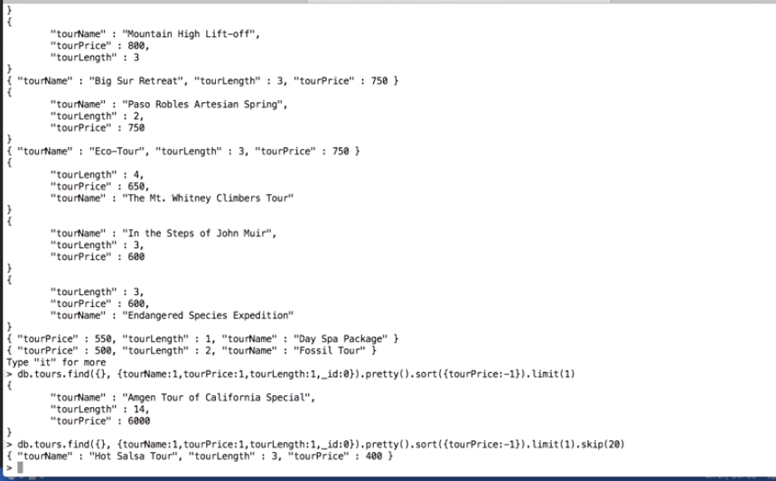

As you might expect, Mongo supports a Limit Operator as well and you can chain it right along with the other functions we have.

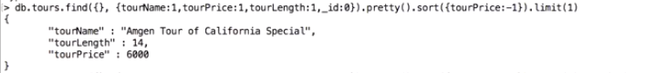

when you're working with a lot of documents, it's frequently necessary to implement paging, so you can add skip to your query to pick documents, other than the first ones returned. Again, we can just chain it on here, skip 20 and we got the Hot Salsa Tour, fantastic.



Here's a couple of other query tips. The tourTags category is made up of an array, but you can still find the documents matching one of the tags.

Mongo handles this in a graceful and straightforward manner,

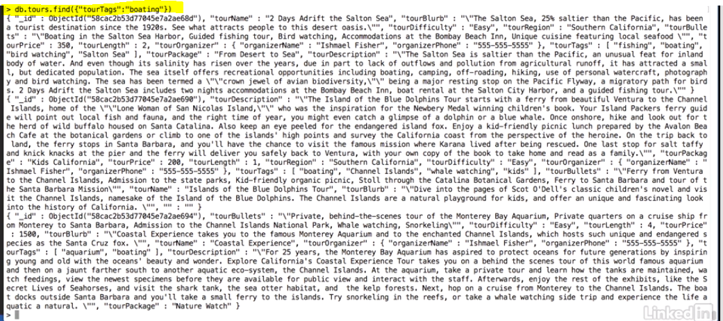

Last, let's take a look at some of the query operators for grabbing documents matching a range of values.  You can use these comparison operators to specify exactly the range of documents you want to see.



# Text indexes and regular expression

let's move on to regular expressions and **searching within text fields**. In order to best support this somewhat expensive operation, let's first create a text index. **A text index, as you would probably expect, indexes the text of the documents in the collection. So, you can search for strings and even use regular expressions with the documents. Note that a collection can have, at most, one text index,though it can include multiple fields.** Pick your field or fields carefully to ensure that clients can access the data they're looking for.

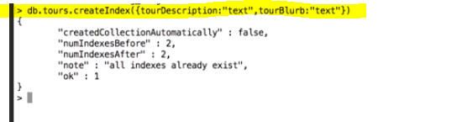

Now, let's find out which of the tours involves wine.

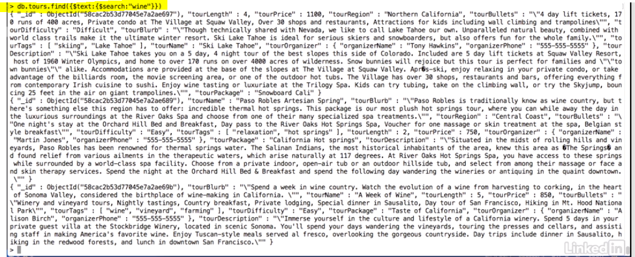

So, we've got all of the tours that involve wine

but what I really want to do is sort them by relevance. **Each document returned by a text search is given a relevance score for use by the Mongo engine.**

We can sort on that to get the best documents of the group. This is a pretty complicated command, so I'll break it down. First, we're going to express the document we want Mongo to return, so we'll use the command we just made. Next, we're going to add a new field to the returnto grab the relevance score. That's stored in a metafield called textScore. So, score:($meta:textScore").



now we have a score, that's great. But we're not sorting 'em by it yet. So, I'm going to go ahead and sort it.



now it's sorted in reverse order by the value of textScore.



There we go, we got the tour name, and the scores, and it's definitely sorting in reverse order.

**Another, more resource-intensive way to find documents, is using a regular expression.** To search for backpack in the tour description, you can use this standard example.

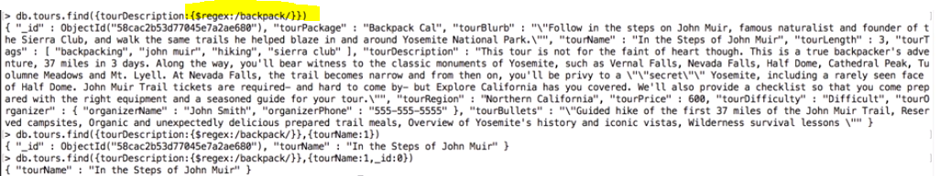

 I'm wondering if there might be any tours where backpack is capitalized. I don't want to miss out, so I'm going to add an option to the regular expression to ignore the case.



There are several different options you can use with regular expressions,but this is one I use quite commonly.

There is a shortcut for regular expressions, so you don't have to put the whole regex field in there. So, the above is exactly equivalent to this,which is a lot easier to type. So, this should give you a good start with text indexes. They can use somewhat more system resources when used, but when you need to search through text fields, text indexes are the way to go.

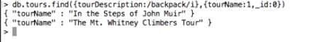

# Model your Schema

**While MongoDB doesn't impose a schema on data being input, it's still necessary for your code to understand the models which are stored in the database. In Node, there's even a library, Mongoose, which interacts with the database under a model-driven interface.Bringing your data into Mongo requires some work in modeling the data to make your queries as efficient as possible and meet the use cases for your clients.**